1) dot product

import numpy as np
def create_matrix(mc):
print("\n ARRAY "+str(mc)+"Elements:")
array_1=map(int,input().split())
array_1=np.array(list(array_1))
print("\n ARRAY"+str(mc)+"ROW COLUMN:")
row,column=map(int,input().split())
if(len(array_1)!=(row*column)):
print("\n Row and column size not match with total elements!!retry")
return create_matrix(mc)
array_1=array_1.reshape(row,column)
print("\n ARRAY"+str(mc))
print(array_1)
return array_1
arr1=create_matrix(1)
arr2=create_matrix(2)
if(arr1.shape == arr2.shape):
print("\n Dot product")
print(np.dot(arr1,arr2))
else:
print("\n dimensions not matching!")

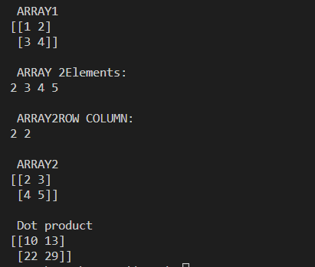

2) Transpose
import numpy as np
def create_matrix(mc):
print("\n ARRAY "+str(mc)+"elements:")
array_1=map(int,input().split())
array_1=np.array(list(array_1))
print("\n array "+str(mc)+",ROWCOLUMN:")
row,column=map(int,input().split())
if(len(array_1)!=(row*column)):
print("\n row and column size not match with total elements!! retry")
return create_matrix(mc)
array_1=array_1.reshape(row,column)
print("\n ARRAY"+str(mc))
print(array_1)
print("\n transpose:")
return (array_1)
print(create_matrix(1).transpose())

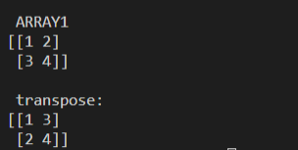

3) feelings
l1=['good','fine','happy','nice','positive']
l2=['bad','frustrated','not','sad','negative']
str1=input('enter your response')
flag=0
ncount=0
pcount=0
t=str1.split()
for i in range(len(t)):
for j in range(len(l1)):
if t[i]==l1[j]:
flag=1
pcount+=1
for k in range(len(l2)):
if t[i]==l2[k]:
flag=1
ncount+=1
if flag==0:
print('you are in another mood')
elif ncount%2==0:
print('positive response')
else:
print('negative response')

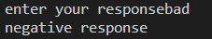
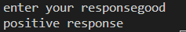
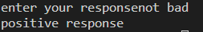

4)Rank
import numpy as np
def create_matrix(mc):
print("\n ARRAY "+str(mc)+"elements:")
array_1=map(int,input().split())
array_1=np.array(list(array_1))
print("\n array "+str(mc)+",ROWCOLUMN:")
row,column=map(int,input().split())
if(len(array_1)!=(row*column)):
print("\n row and column size not match with total elements!! retry")
return create_matrix(mc)
array_1=array_1.reshape(row,column)
print("\n ARRAY"+str(mc))
print(array_1)
print("\n Rank:")
return (array_1)
print(np.linalg.matrix_rank(create_matrix(1)))
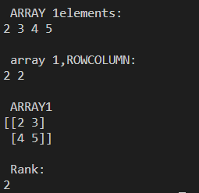

5)KNN
from sklearn.neighbors import KNeighborsClassifier
from sklearn.model_selection import train_test_split
from sklearn.datasets import load_iris
irisdata=load_iris()
x=irisdata.data
y=irisdata.target
x_train,x_test,y_train,y_test=train_test_split(x,y,test_size=0.2,random_state=42)
knn=KNeighborsClassifier(n_neighbors=3)
knn.fit(x_train,y_train)
print(knn.predict(x_test))
print(knn.score(x_test,y_test))
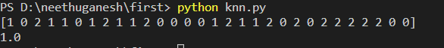

6)KNN 2
from sklearn.neighbors import KNeighborsClassifier
from sklearn.model_selection import train_test_split
x=([1],[2],[3],[4],[5],[6],[7],[8],[9],[10])
y=[1,4,9,16,25,36,49,64,81,100]
x_train,x_test,y_train,y_test=train_test_split(x,y,test_size=0.2,random_state=42)
knn=KNeighborsClassifier(n_neighbors=1)
knn.fit(x_train,y_train)
print(x_test)
print(knn.predict(x_test))
print(knn.score(x_test,y_test))
